Grade 8 ICT Python Exercise

Name: Class: Date:

Write a Python program to get a single string from two given strings, separated by a space and swap the first two characters of each string.
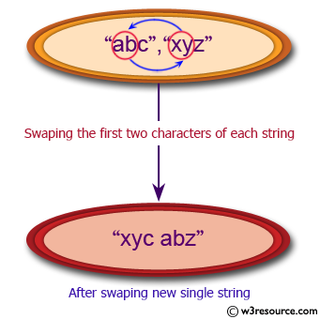

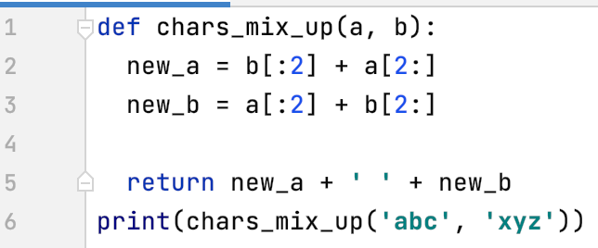

Screenshot of Code | Screenshot of output

Write a Python program to add 'ing' at the end of a given string (length should be at least 3). If the given string already ends with 'ing' then add 'ly' instead. If the string length of the given string is less than 3, leave it unchanged.
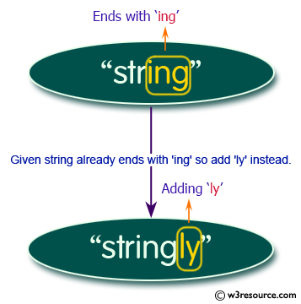

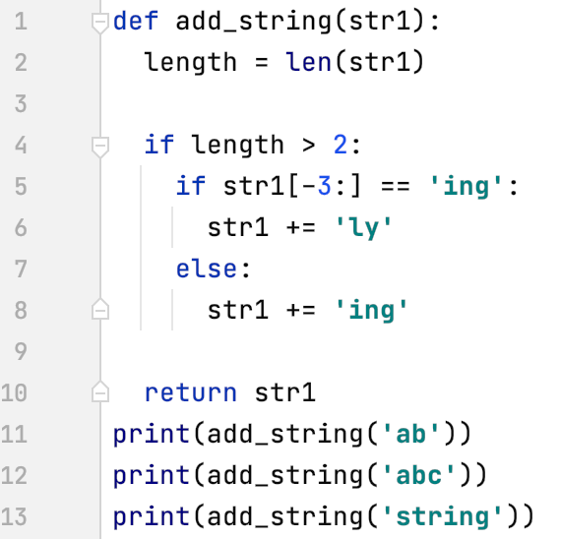

Screenshot of Code | Screenshot of output

3. Write a Python program to that reads a date (from 2016/1/1 to 2016/12/31) and prints the day of the date. Jan. 1, 2016, is Friday. Note that 2016 is a leap year.
Input:
Two integers m and d separated by a single space in a line, m ,d represent the month and the day.
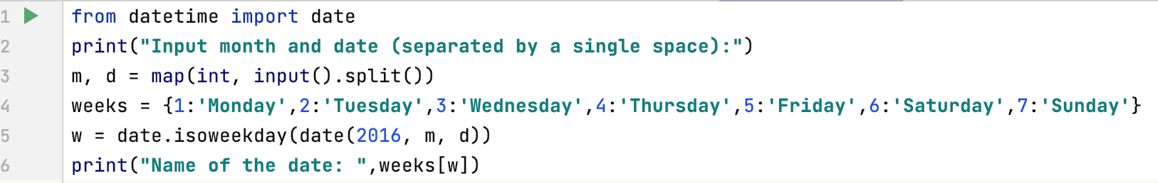
Screenshot of Code | Screenshot of Output (Run)

